Develop your reading skills. Read the following text about Ramadan. Then answer the comprehension questions.

Reading Comprehension – Ramadan

Ramadan is the ninth month of the Islamic calendar. It is the Islamic month of fasting, in which participating Muslims refrain from eating, drinking from dawn until sunset. Ramadan had been the name of the ninth month in Arabian culture long before the arrival of Islam. In the Qur'an it is said that "fasting has been written down (as obligatory) upon you, as it was upon those before you" which is a reference to the Jewish practice of fasting on Yom Kippur. Fasting is meant to teach the Muslim patience, modesty and spirituality.
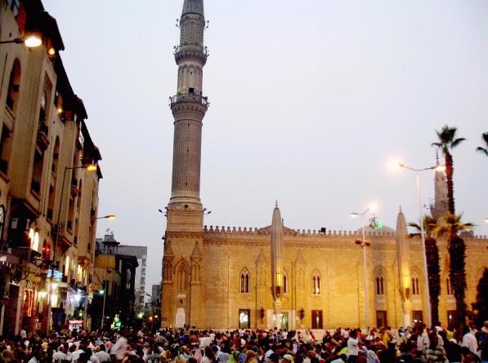
Ramadan is a time for Muslims to fast for the sake of God and to offer more prayer than usual. During Ramadan, Muslims ask forgiveness for past sins, pray for guidance and help in refraining from everyday evils, and try to purify themselves through self-restraint and good deeds.
As compared to the solar calendar, the dates of Ramadan vary, moving backwards about ten days each year as it is a moving holiday depending on the moon. Ramadan was the month in which the first verses of the Qur'an were said to be revealed to the Islamic Prophet Muhammad. That was during a night that Muslims call Laylat al-Qadr (the night of decree or measures.) The night is believed to be one of the 10 last days of the month.
Ramadan ends with Eid ul-Fitr on the first of Shawwal, with much celebration and feasting.

Comprehensions
1. Ramadan was introduced after Islam had appeared.
a. True
b. False
- Ramadan comes on a fixed date every year.
a. True
b. False
3. In Ramadan Muslims don't fast all day long.
a. True
b. False
- Muslims believe that the Qur'an was revealed during the first nights of Ramadan.
a. True
b. False

What is Ramadan?
Fill in the blanks
---------------- is the ---------------- month in the Muslim calendar. At this time, Muslims will ------------- during ------------------ hours for the whole month. During Ramadan, Muslims celebrate the time when the verses oh their holy book, the ------------------ were revealed to the prophet-----------------------.
Muslims fast during Ramadan to help them remember poorer people and to be more ------------------, ---------------------- and more generous. As well as fasting, they will spend lots of time ---------------- and -------------- the Quran. They will also try to do -------------------- and will give money to charity.
Ramadan is a time to spend with --------------- and family, too. Often the fast is broken by several families coming together. The first meal eaten after sunset is called the --------------- this often consists of ----------------. A bigger meal will also be eaten in the evening.
At the end of Ramadan there is a big festival called ------------ -------------. The fasting is over. People were their best -------------- and give ------------ to children. They must also give money to -------------- for the poor, so they can celebrate too. Friends and family will gather to celebrate.
Eid- ul- fitr fast Ramadan Muhammad
Self-disciplined friends good deeds daylight
Praying dates clothes gifts
Ninth Quran Iftar charity
Reading

Match between the word and the meaning
Words meaning
صدقة
fast
هدايا
praying
التقويم
sunset
يدعو
charity
صوم
Sunrise
غروب الشمس
Self-disciplined
شروق الشمس
Gifts
انضباط الشمس
Good deeds
الاعمال الصالحة
Calendar

